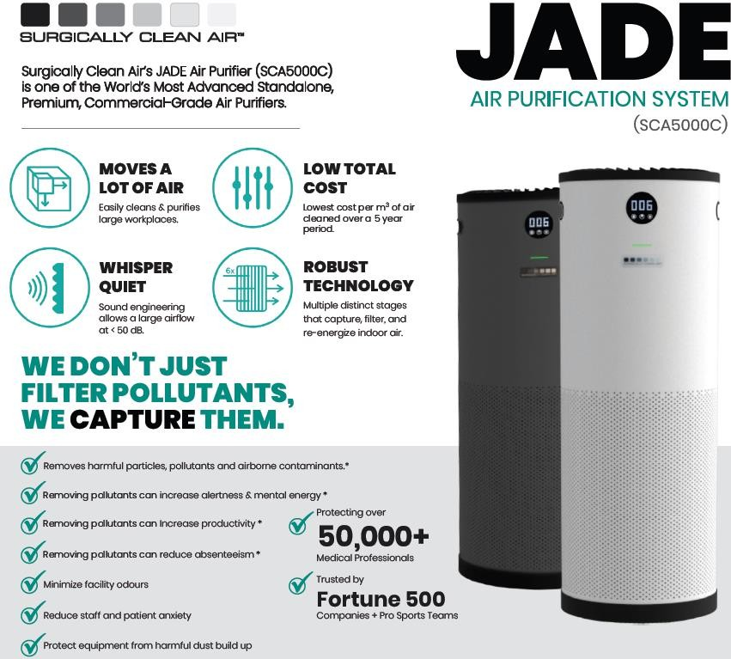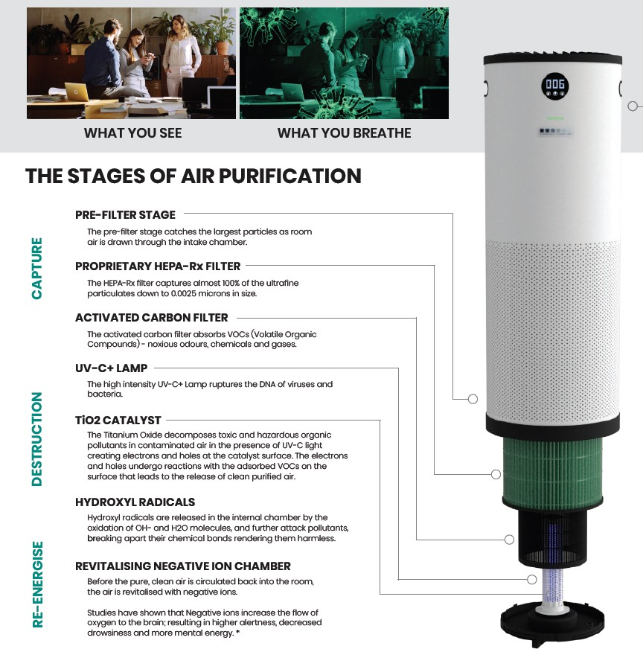

Jade 1.0 SCA5000C - Updated Air Purifier Information
674pcs x Jade 1.0 Air Purifier Advanced Filteration for Clean Healthy Air – White……...Selling on eBay for £449.95
429pcs x Jade 1.0 Air Purifier Advanced Filteration for Clean Healthy Air – Black……...Selling on eBay for £449.95
Youtube Link to our product - HoneyWarm UK V27 B3 16x9 VO1 M1

